Lab 8 Exercise

User stories

* *"As a user, I want to select a type of dice (e.g., D6, D10) so I can choose how many sides it has."*
* *"As a user, I want to click a button to roll the dice so I can get a random result."*
* *"As a user, I want to see the result displayed on the screen clearly."*
* *"As a user, I want to see an image or animation representing the dice roll so the experience feels more interactive."*
* *"As a user, I want to be able to roll multiple types of dice without reloading the page."*

Storyboard

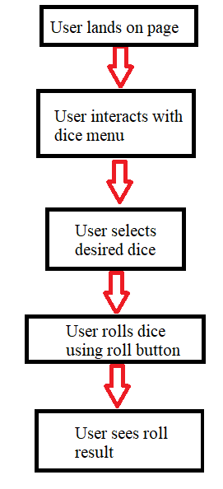

Creation of repository:

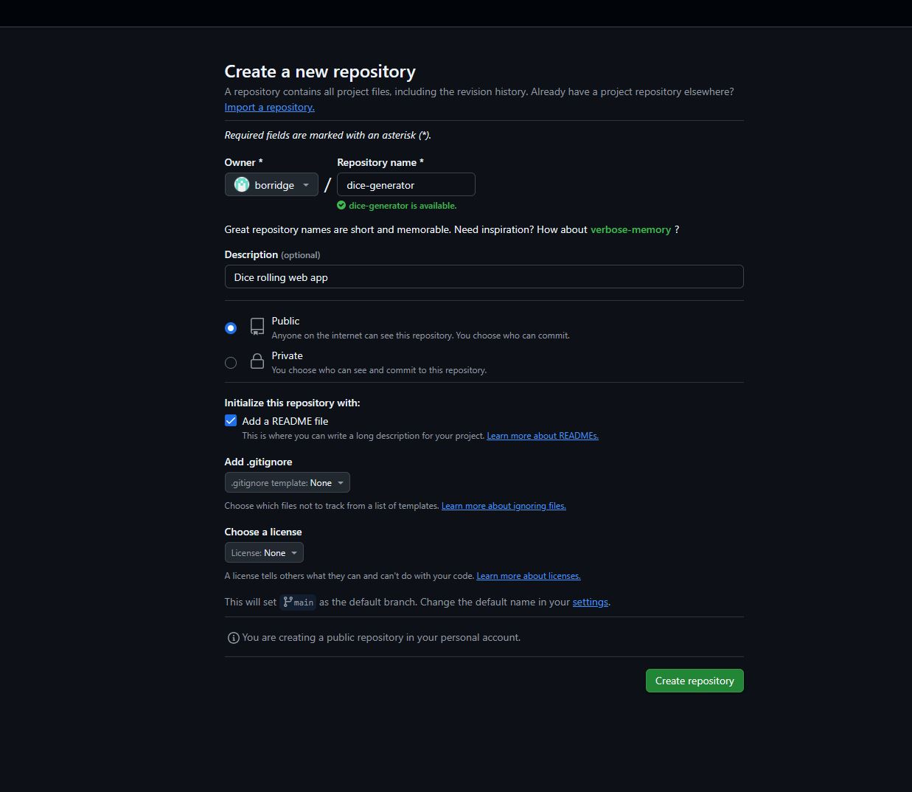

**Clone:**

git clone https://github.com/borridge/dice-generator.git

cd dice-generator

**Creation of two branches**

**UI:**

C:\Software Engineering\Module1\dice-generator> git checkout -b ui

git add . (adds all files)

git commit -m "Add dice UI layout"

git push origin ui-feature

git checkout main

git merge ui-feature # Merge into main

Logic:

git checkout main

git checkout -b roll-logic

git add js/rollDice.js

git commit -m "Add rollDice function with unit tests"

**Merge:**

git checkout main

git merge ui -m "Merge UI branch"

git merge roll-logic -m "Merge roll logic branch"

**Push to github:**

git push origin main

for other branches:

git push origin ui

git push origin roll-logic

Reuseability

/**

* Rolls a dice with a given number of sides

* @param {number} sides - Number of sides on the dice

* @returns {number} - Random result between 1 and sides

*/

function rollDice(sides) {

return Math.floor(Math.random() * sides) + 1;

}

Unit testing

console.log("Unit tests for rollDice()");

// Test with D6

let result = rollDice(6);

console.assert(result >= 1 && result <= 6, "D6 failed");

// Test with D20

result = rollDice(20);

console.assert(result >= 1 && result <= 20, "D20 failed");

// Test with invalid sides (edge case)

result = rollDice(1);

console.assert(result === 1, "D1 should always return 1");

// Optional: Add check for negative or non-number inputs if you want validation

Final push

git add .

git commit -m "Complete dice generator with UI and logic"

git push origin main